
System Algorithms and Definitions
March 21, 2011

This is a working document that serves to define various algorithms that Systems under ICARUS follow. For Symbol Definitions, see Document on DropBox:
Dropbox\ICARUS\Engineering\System Programming\ System Definitions.doc
All numbers to be defined are represented by “xx”.

System Algorithms

Vehicle

FLIGHT MODE – NORMAL

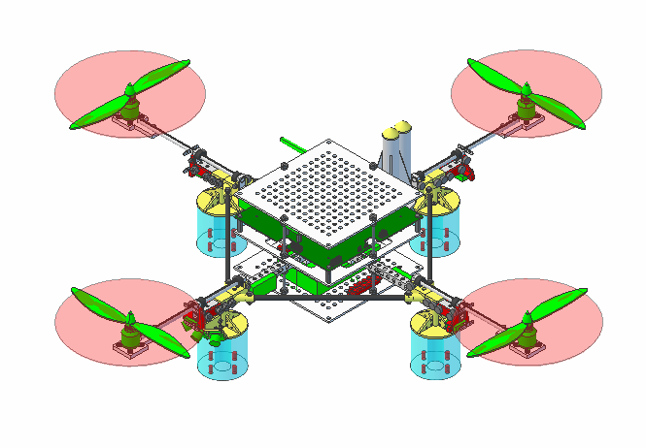
Pilot wishes to adjust: | Vehicle performs:
Increase Pitch | Increase Front pylon motor speed, Decrease Rear pylon motor speed
Roll Left | Increase Right motor speed, Decrease Left Pylon motor speed
Yaw Left | Increase Front/Rear motor speed, Decrease Left/Right motor speed
Increase speed of Vehicle | Increase speed of all motors
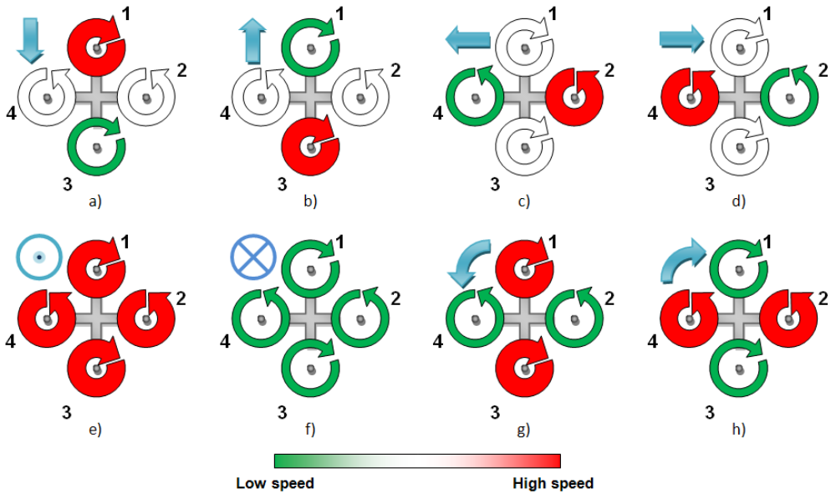

Direct Manual Control

Primary and Secondary Controller
- Primary Controller Receives Packet (Wireless): $MAN
  - Transmit $MAN Φ: Y,P,R; Throttle packet to Secondary Controller
  - Transmit xx Wireless
- Secondary Controller Receives Packet: $MAN [Y,P,R,Throttle]
  - Convert Y,P,R, Throttle to PWM scale
    - Ys = (Y + 90) * 1000/180
    - Ps = (P+90) * 1000/180
    - Rs = (R+90) * 1000/180
    - Tis = (Throttle * 1000/100)
  - Map Command Signals to Motor Values
    - Ω:1,2 = ((Ps – 500)/2 + (Ys – 127)/2 + (Ts + 500)/2)
    - Ω:3,4 = ((Rs – 500)/2 + (500 – Ys)/2 + (Ts + 500)/2)
    - Ω:5,6 = ((500 – Ps)/2 + (Ys – 500)/2 + (Ts + 500)/2)
    - Ω:7,8 = ((500 – Rs)/2 + (500 – Ys)/2 + (Ts + 500)/2)
  - Transmit Heading to Primary Controller

Secondary Controller Only
Vehicle is capable of flying with Primary Controller removed or when Primary Controller is non-operational (i.e. when Primary Controller is receiving a firmware update or enters a corrupted state).
As the advanced functionality of the Primary Controller will be unavailable, Vehicle will not be able to perform any Semi-Autonomous or Autonomous actions. Vehicle enters FLIGHT MODE – NORMAL, Direct Manual Control, Secondary Controller Only when any of the following conditions exist:

- Vehicle powers ON and Secondary Controller receives no “Keep Alive” packets from Primary Controller.
- Vehicle is operational and receives no “Keep Alive” packets for > xx seconds

When Vehicle enters this FLIGHT MODE, it will perform the following operations:
- Enable PROP_COM_SEL pin, commanding Radio Multiplexer to transmit/receive to Secondary Controller.
- Secondary Controller Receives Packet: $MAN Φ: Y,P,R; Throttle
  - Convert Y,P,R, Throttle to PWM scale
    - Ys = (Y + 90) * 1000/180
    - Ps = (P+90) * 1000/180
    - Rs = (R+90) * 1000/180
    - Tis = (Throttle * 1000/100)
  - Map Command Signals to Motor Values
    - Ω:1,2 = ((Ps – 500)/2 + (Ys – 127)/2 + (Ts + 500)/2)
    - Ω:3,4 = ((Rs – 500)/2 + (500 – Ys)/2 + (Ts + 500)/2)
    - Ω:5,6 = ((500 – Ps)/2 + (Ys – 500)/2 + (Ts + 500)/2)
    - Ω:7,8 = ((500 – Rs)/2 + (500 – Ys)/2 + (Ts + 500)/2)
- Transmit xx Wireless

Semi-Autonomous Control

Primary and Secondary Controller
- Primary Controller Receives Packet (Wireless): $MAN
- Transmit $MAN Φ[P,R,Y], Throttle packet to Secondary Controller
- Transmit xx Wireless
- Primary Controller Receives Packet (Wireless): $CON,OFF;$CON,TAKEOFF;$CON,HOVER;$CON,LAND;
  - $CON,TAKEOFF: ENTER FLIGHT MODE – TAKING OFF
  - $CON,HOVER: ENTER FLIGHT MODE- HOVERING
  - $CON,LAND: ENTER FLIGHT MODE - LANDING
- Secondary Controller Receives Packet: $MAN Φ: Y,P,R; Throttle
  - Convert Y,P,R, Throttle to PWM scale
    - Yi = (Y + 90) * 255/180
    - Pi = (P+90) * 255/180
    - Ri = (R+90) * 255/180
    - Ti = (Throttle * 255/100)
- Secondary Controller Receives Packet: $SEN,INU φ[P,Y,R] : Yc,Pc,Rc
  - Computer Error History:
    - PerrorHistory += (Pc – Pi)
    - YerrorHistory += (Yc – Yi)
    - RerrorHistory += (Rc – Yi)
  - Calculate PID Angles
    - Px = PID(PIDK[Pitch], PerrorHistory, Pc, Pi)
    - Yx = PID(PIDK[Roll], YerrorHistory, Yc, Yi)
    - Rx = PID(PIDK[Roll], RerrorHistory, Rc, Ri)
  - Map Calculated PID Angles to Motor Commands
    - Ω:1,2 = ((Px – 127)/2 + (Yx – 127)/2 + (Ti + 127)/2)
    - Ω:3,4 = ((Rx – 127)/2 + (127 – Yx)/2 + (Ti + 127)/2)
    - Ω:5,6 = ((127 – Px)/2 + (Yx– 127)/2 + (Ti + 127)/2)
    - Ω:7,8 = ((127 – Rx)/2 + (127 – Yx)/2 + (Ti + 127)/2)
  - Read Ultrasonic Distance to Ground/Objects
  - Read Altimeter Height
  - Transmit Heading to Primary Controller
  - Transmit Ultrasonic Distance to Primary Controller

Autonomous Control

FLIGHT MODE – TAKING OFF

Primary and Secondary Controller

Vehicle enters FLIGHT MODE – TAKING OFF when Commanded by GCS, RCU or itself. Vehicle performs the following operations:
- Secondary Controller ramps Throttle until Accelerometer reads vertical acceleration:
  - Ω:1,2 = PID(Φ[0,0,0],Throttle)
  - Ω:3,4 = PID(Φ[0,0,0],Throttle)
  - Ω:5,6 = PID(Φ[0,0,0],Throttle)
  - Ω:7,8 = PID(Φ[0,0,0],Throttle)
- NOTE: At This Throttle Command, Minimum Hover Power = Throttle.
- Secondary Controller maintains Throttle until Ultrasonic Distance indicates Height Above Ground (HAG) at > xx feet.
- Vehicle enters FLIGHT MODE - HOVERING

FLIGHT MODE – HOVERING
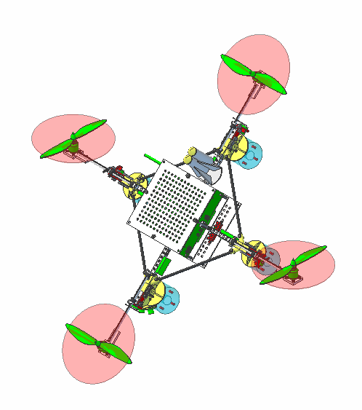
Pilot wishes to adjust: | Vehicle performs:
Increase Pitch | Rotate Left/Right Pylon Servo’s, Front/Rear Motor speeds = 0
Roll Left | Rotate Front/Rear Pylon Servo’s, Left/Right Motor speeds = 0
Yaw Left (at Horizontal) | Increase Front/Rear motor speed, Decrease Left/Right motor speed

Primary and Secondary Controller

Vehicle enters FLIGHT MODE – HOVERING when Commanded by GCS, RCU or itself. Vehicle performs the following operations:
- Primary Controller Receives Packet (Wireless): $MAN
  - Transmit $MAN Φ[P,R,Y], Throttle packet to Secondary Controller
  - Transmit xx Wireless
- Secondary Controller adjusts Throttle Command to
  - Ω:1,2 =
  - Ω:3,4 =
  - Ω:5,6 =
  - Ω:7,8 =

Secondary Controller Only

Vehicle enters FLIGHT MODE – HOVERING when Commanded by GCS, RCU or itself. Vehicle performs the following operations:
- Secondary Controller adjusts Throttle Command to Minimum Hover Power.
  - Ω:1,2 = PID(Φ[0,0,0],Throttle)
  - Ω:3,4 = PID(Φ[0,0,0],Throttle)
  - Ω:5,6 = PID(Φ[0,0,0],Throttle)
  - Ω:7,8 = PID(Φ[0,0,0],Throttle)

FLIGHT MODE – LANDING

Semi-Autonomous Control

Primary and Secondary Controller

Autonomous Control

Automatic Landing Pad, Primary and Secondary Controller

Primary and Secondary Controller

FLIGHT MODE – DIAGNOSTIC
Vehicle enters FLIGHT MODE – DIAGNOSTIC when Commanded by GCS, RCU or itself.
Vehicle concurrently enters FLIGHT MODE – HOVERING, SECONDARY CONTROLLER ONLY
Vehicle initiates the following actions:
- Secondary Controller maintains operation of Communications Processor and PWM Processor.
  - Secondary Controller Diagnostic sub-routines started.
  - When complete, transmit any Errors Wirelessly.
- Primary Controller maintains operation of Communications
- Primary Controller Diagnostic sub-routines started.
- When complete, transmit any Errors Wirelessly.
- If no Errors on Secondary Controller and some Errors on Primary Controller
  - Transfer Communications Command to Secondary Controller
  - Reboot Primary Controller
- If no Errors on Primary Controller and Secondary Controller, enter FLIGHT MODE –HOVERING, PRIMARY AND SECONDARY CONTROLLER.
- Transmit Diagnostic Success Message wirelessly.

FLIGHT MODE – CRUISE
Vehicle mimics normal airplane by producing lift on front/back pylons to counter-act weight of Vehicle and generates forward motion from left/right pylons.
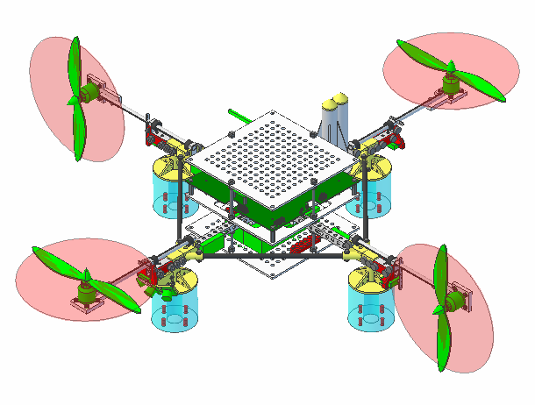

Pilot wishes to adjust: | Vehicle performs:
Increase Pitch | Increase Front pylon motor speed, Decrease Rear pylon motor speed
Roll Left | Rotate Right Pylon Backwards, Rotate Left Pylon Forwards
Yaw Left | Increase Right pylon motor speed, Decrease Left pylon motor speed
Increase Vertical speed of Vehicle | Increase Front/Rear pylon motor speed.
Increase forward speed of Vehicle | Increase Left/Right pylon motor speed OR Rotate Left/Right Pylons to 90 deg.

Semi-Autonomous Control

Primary and Secondary Controller
Vehicle enters FLIGHT MODE – CRUISE when Commanded by GCS, RCU or itself. Vehicle must be capable of rotating Rotors. Vehicle performs the following operations:
- Secondary Controller adjusts Throttle Command to Minimum Hover Power.
  - Ω:1,2 = PID(Φ[0,0,0],Throttle)
  - Ω:3,4 = PID(Φ[0,0,0],Throttle)
  - Ω:5,6 = PID(Φ[0,0,0],Throttle)
  - Ω:7,8 = PID(Φ[0,0,0],Throttle)
- Secondary Controller rotates Left/Right Pylons Forward increasing Throttle on Front/Back Pylons to make up for reduced Lift from Left/Right Pylons and reducing Throttle on Left/Right Pylons.
  - At full rotation, Left/Right Pylons should have 0 Throttle and Front/Back Pylons should have Throttle increased where vertical acceleration is equal to 1 g. (e.g. Vehicle should appear “weightless; Thrust == Weight).
- Primary Controller Receives Packet (Wireless): $MAN
- Transmit $MAN Φ[P,R,Y], Throttle packet to Secondary Controller
- Transmit xx Wireless
- Secondary Controller Servos and Motors
  - σ:1 =
  - σ:2=
  - σ:3=
  - σ:4=
  - Ω:1,2 =
  - Ω:3,4 =
  - Ω:5,6 =
  - Ω:7,8 =

GCS

FLIGHT MODE – NORMAL

FLIGHT MODE – TAKING OFF

FLIGHT MODE – HOVERING

FLIGHT MODE – DIAGNOSTIC

FLIGHT MODE – CRUISE

RCU

FLIGHT MODE – NORMAL

FLIGHT MODE – TAKING OFF

FLIGHT MODE – HOVERING

FLIGHT MODE – DIAGNOSTIC

FLIGHT MODE – CRUISE

Sub-Routines
PID(Decimal[] PIDK, Decimal ErrorHistory, Decimal CurrentValue, Decimal CommandValue) |Returns Decimal NewValue

Inter-System Algorithms

Indicators

Main LED Indicator
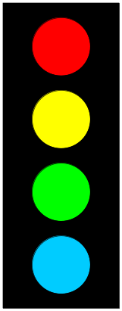
Red: On upon Error
Yellow: Blinks during Boot Process
Green: Blinks during Manual Mode
Blue: Blinks during any Semi or Auto Mode
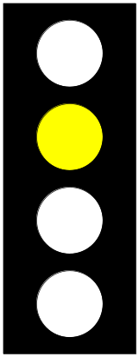

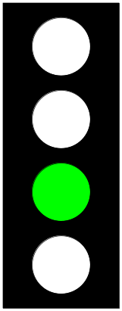

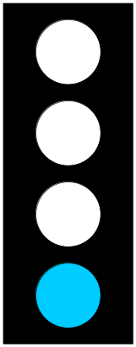

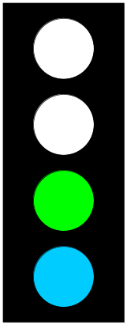

Flight Modes
Each FLIGHT MODE has a corresponding priority, in the following order:
- EMERGENCY RECOVERY
- EMERGENCY LANDING
- NO COMMUNICATIONS
- DIAGNOSTIC
- LANDING
- All Other FLIGHT MODES.

NORMAL
Vehicle: Everything Normal. No Error Conditions.

TAKING OFF
Vehicle: Everything Normal. No Error Conditions.

HOVERING
Vehicle: Everything Normal. 2 Options:
- Receive Yaw, Throttle commands and attempt to keep Altitude constant.
- Rotate Tilt-Rotors to FLIGHT MODE – CRUISE.

LANDING
Vehicle: Everything Normal. No Error Conditions.
OR

DIAGNOSTIC
Vehicle enters FLIGHT MODE – DIAGNOSTIC when any of the following conditions exist:
- Vehicle attempting to exit out of the following FLIGHT MODES to FLIGHT MODE – NORMAL:
  - FLIGHT MODE – NO COMMUNICATIONS
  - FLIGHT MODE – EMERGENCY LANDING
  - FLIGHT MODE – EMERGENCY RECOVERY
- Initiated by GCS or RCU
- Vehicle should enter FLIGHT MODE – HOVER concurrently.

CRUISE

NO COMMUNICATIONS
Vehicle enters this mode when any of the following conditions exist:
- No Communications for xx Seconds.
- Packet loss per second > xx packets

EMERGENCY LANDING
Vehicle attempting Emergency Landing operation due to one or more of the following reasons:
- No Communications for xx Seconds.
- Battery Voltage < xx and Altitude over Ground > xx.
- Pitch,Roll,Yaw,Throttle or Altitude over Ground uncontrollable.
- Loss of Critical Components: Primary Controller, GPS.

Vehicle Initiates the following actions:
- Complete FLIGHT MODE - LANDING
- Start Self-Diagnostics
- Start GPS Beacon

EMERGENCY RECOVERY
Vehicle attempting Emergency Recovery operation due to one or more of the following reasons:
- EMERGENCY LANDING Procedure not appropriate or not possible.
- No Communications for X Seconds.
- Battery Voltage < X and Altitude over Ground > X.
- Pitch,Roll,Yaw,Throttle or Altitude over Ground uncontrollable.
- Loss of Critical Components: Secondary Controller, Main ESC’s.

Vehicle Initiates the following actions:
- Attempt remove power from Motors.
- Deploy Parachute
- Deploy Flare
- Start GPS Beacon

